News Article Classification (Fake/Real) Using Machine Learning

1. Introduction
Fake news spreads misinformation on social media. Detecting fake news automatically helps prevent misinformation.

2. Objective
To build a machine learning model that classifies news as real or fake using text data.

3. Tools Used
- Python
- Pandas
- Scikit-learn
- NLTK

4. Dataset
Fake and Real News Dataset from Kaggle containing thousands of real and fake news articles.

5. Steps In Building Project
- Load datasets
- Label fake news as 0 and real news as 1
- Convert text into numeric format using TF-IDF
- Split data into training and testing sets
- Train Logistic Regression model
- Evaluate accuracy
- Save trained model

6. Result
The model achieved approximately 98% accuracy in detecting fake news.
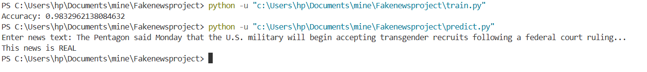

7. Conclusion
Machine learning can effectively detect fake news using text patterns.

8. References
Kaggle Fake News Dataset
Scikit-learn Documentation

